Top of Form
Click for More desktop | < Prev Showing 8 of 11 Next >

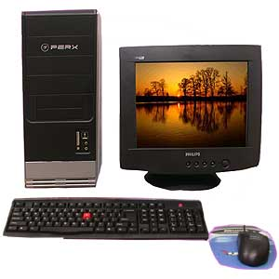
  Intel Celeron Processor
  SKU : ENR053
  Qty : 1 Pc Set
  Price : Rs 19,379.00
  Brand : Intel
  
  
  Shipping
  Delivery All Over INDIA only
  Free Shipping to India

Product Description
- Intel Celeron Processor Free 3 Days 2 Nights Holiday Gift Vouchers.
- Processor : Intel Celeron 2 Ghz. Processor Motherboard : 845 Chipset Compatible MotherBoard.
- Memory : 128MB DDR RAM
- Hard Disk : 40GB Segate Hard Drive
- ODD : 52x CD Rom Drive
- Graphics : High Performance Integrated Graphics Inbuilt
- Monitor : 15 Inch SVGA CRT Colour Monitor
- Network : 10/100 Fast Ethernet Port for networking
- Sound : 2 Channel Sound Onboard
- Peripherals : 104 Keys Keyboard, Scroll Wheel Mouse
- Ports : USB2.0 Ports x4, Parallel & Standard Ports
- Cabinet : Full ATX Tower Case.
Please Note:
- Please allow 3 - 4 working days to be shipped.
- Prices include taxes and delivery charges.
Applicable Octroi charges if any, will be collected from the consignee
Bottom of Form

